

Lab-02: Network Scanning with Nmap

Tatiana Meneses

31 de outubro, 2024

# Overview

Each device on a network has a unique MAC address, which acts as its hardware identifier. In cybersecurity, attackers may attempt to impersonate an authorized device by changing their device’s MAC address, a technique known as MAC spoofing. Understanding MAC tables enables network administrators to monitor for and detect such anomalies, often indicating unauthorized access attempts.

Switches operate by managing and controlling access to the network. Unlike routers, which use IP addresses, switches rely on MAC addresses. Understanding MAC addresses and switch behavior is crucial to managing network access and preventing unauthorized devices from gaining connectivity.

In this exercise, you will create and configure VLANs on a Cisco 2960 switch in Packet Tracer. You’ll set up three groups of devices (Students, Teachers, and Default) with specified IP addresses, configure VLANs, assign devices to the appropriate VLAN, and test connectivity between them.

## Part 1: Setting Up the Network Topology

**Steps:**Create the Topology:

* Open Cisco Packet Tracer and create the following devices:
  + 1 Cisco 2960 Switch.
  + 2 PCs for the Student VLAN.
  + 2 PCs for the Teacher VLAN.
  + Three Devices (2 PCs and 1 Laptop) for the Default VLAN.

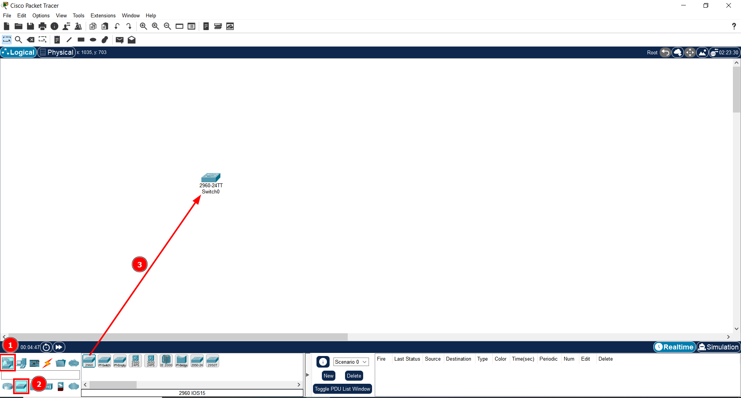

1. First we select the button Network Devices;
2. Inside Network Devices, we select the button Switches;
3. Inside Switches we can find several types of switches. We click on the option 2960 and drag it to the white canva;
4. And the Cisco 2960 Switch is created;

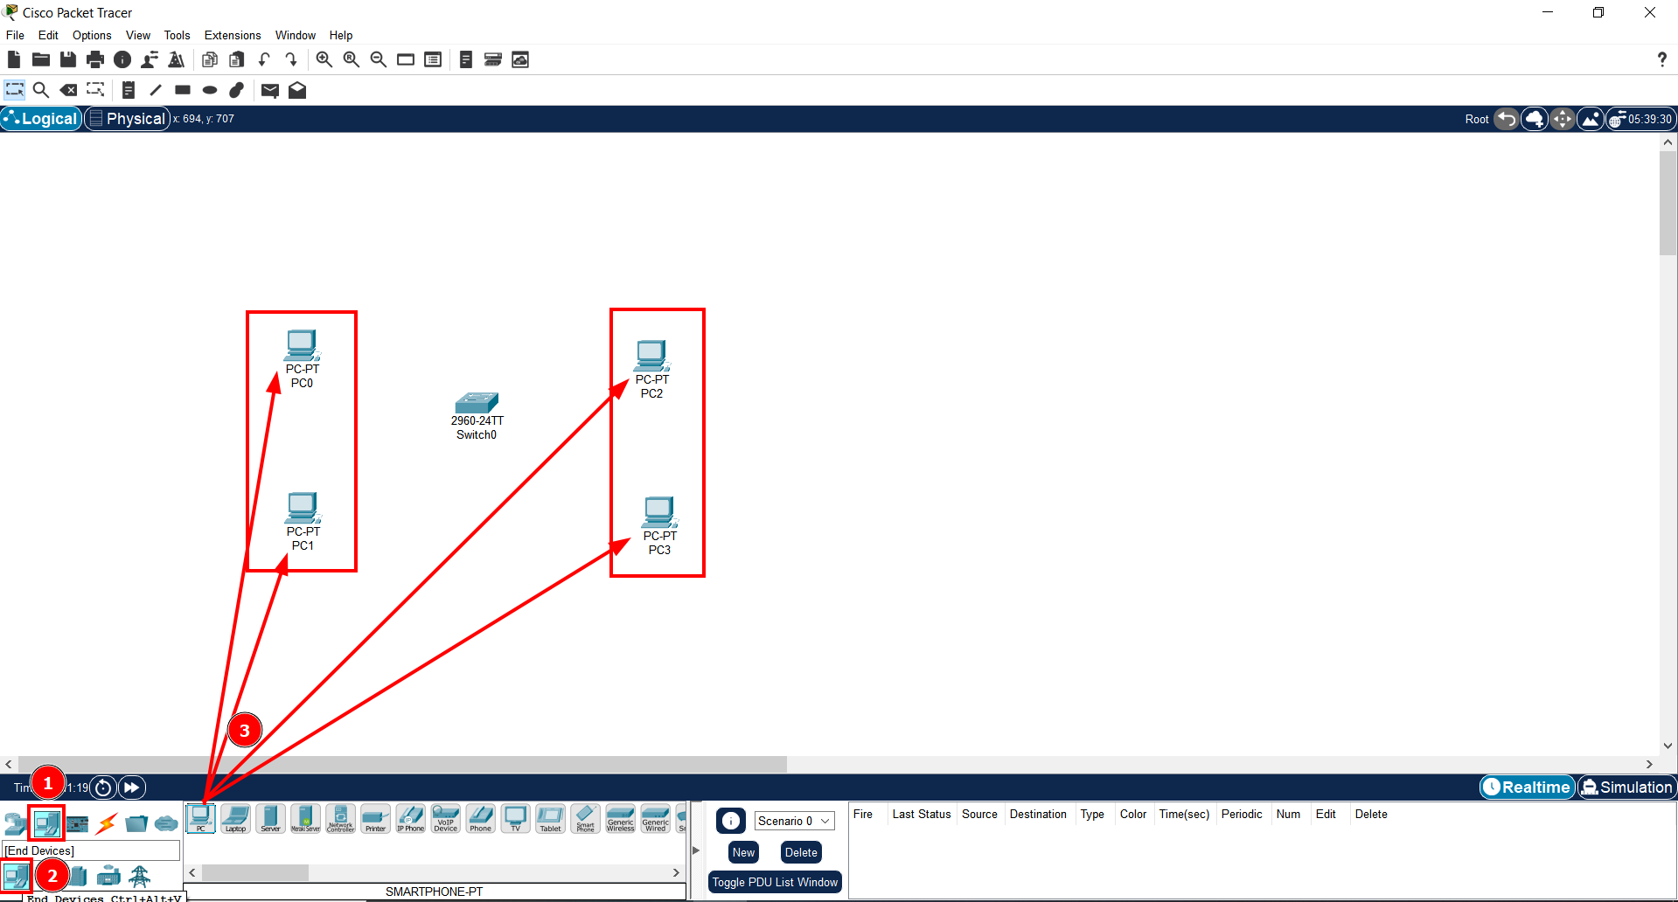

1. To create the PC’s, we select the button End Devices;
2. And then the second End Devices button;
3. To create the PC’s on the white canvas, we select the option first option that appears and drag it;
4. Now we have 4 PC’s created (2 PC’s for the Student parameter and 2 PC’s for the teacher parameter);

### Assign IP Addresses:

* Configure the IP addresses for each device as follows:

**Student VLAN (VLAN 10)**

* PC1: 192.168.10.10
* PC2: 192.168.10.11

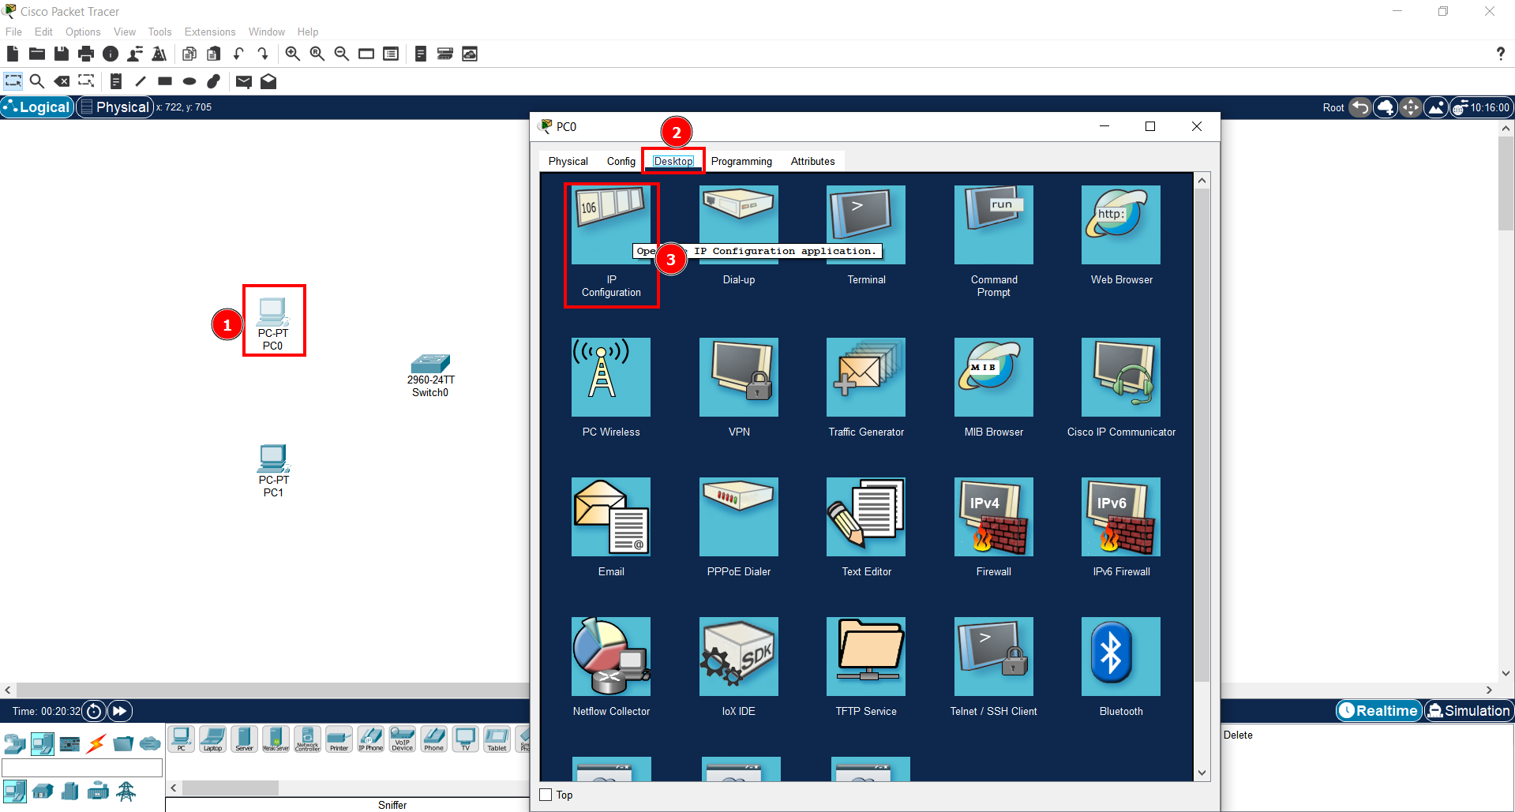

1. To configure the IP address for the first PC, we click on the device and another window will open;
2. On the top menu, we select the tab that says Devices;
3. Inside this tab, we select the option IP Configuration;

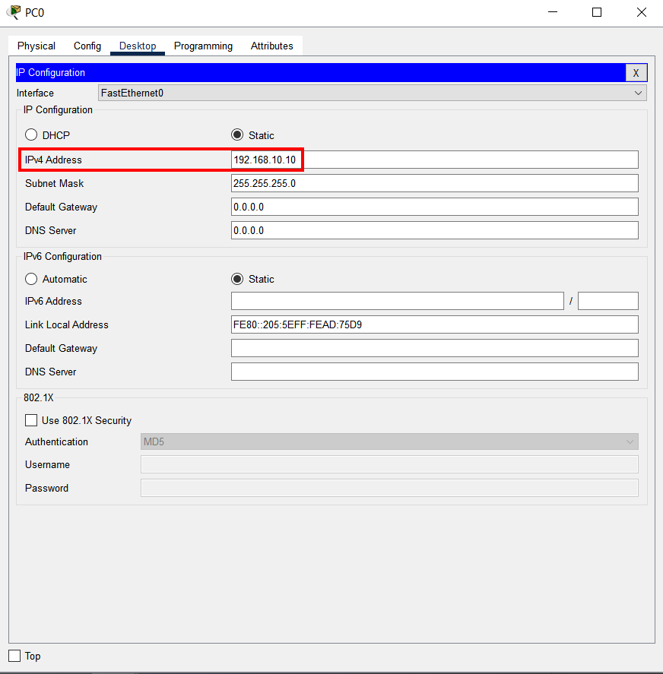

1. Inside this window, we can assign an IP address to this device. In this case I assigned the IP address that will designate the Student PC1;

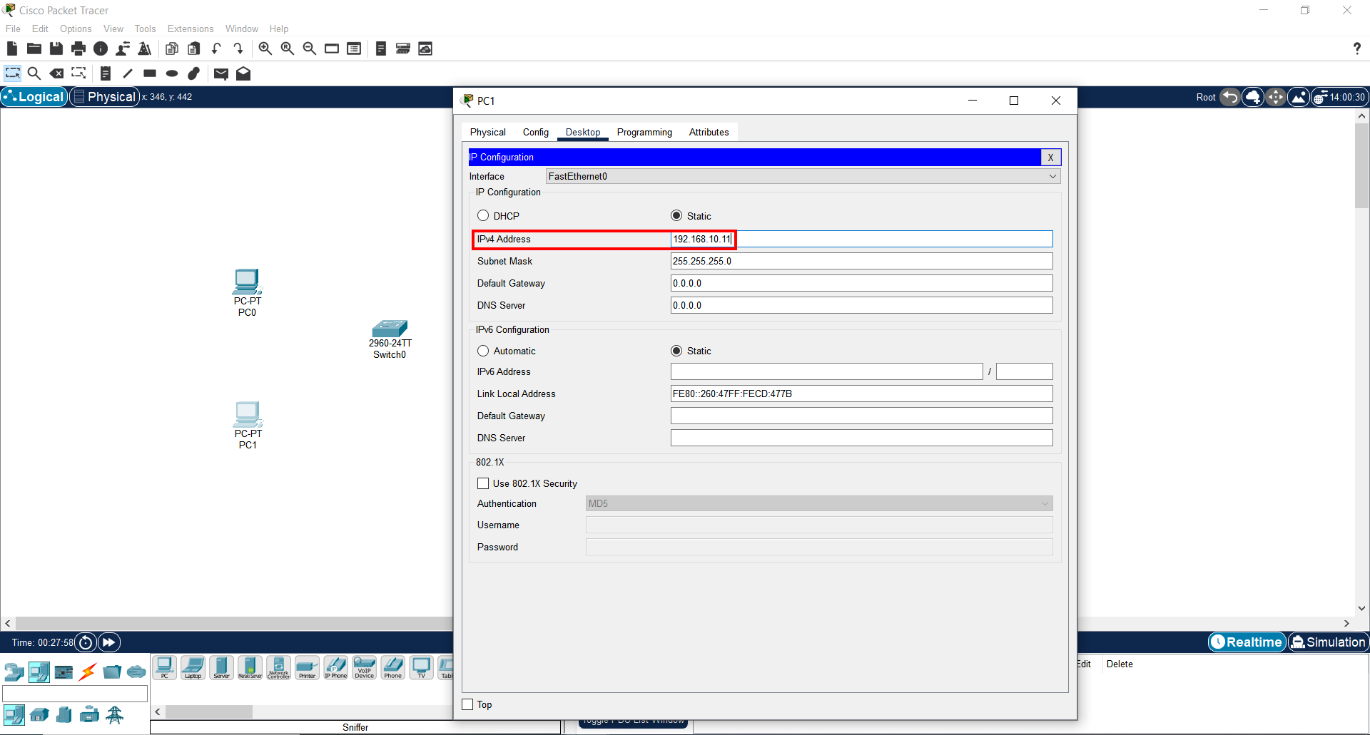

1. IP address assigned to the Student PC2;

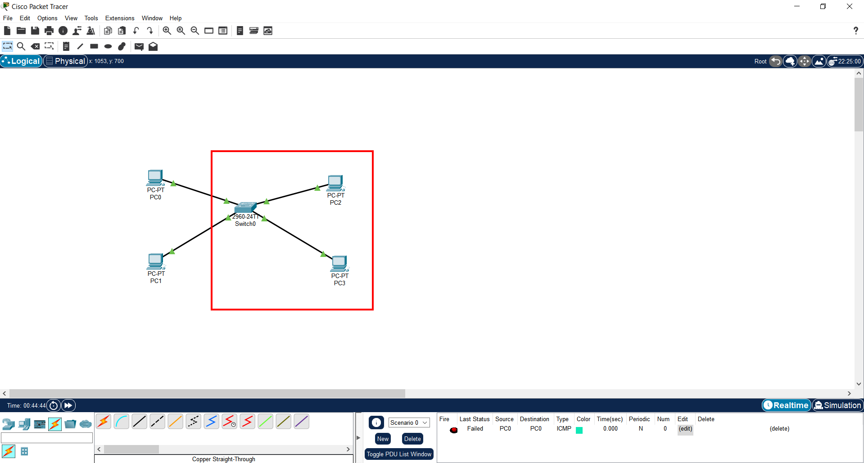

1. The same procedure is made to make a connection between the switch and the 2 Teacher PC’s;

**Important Note**: The procedure made to assign the IP address to the Students PC’s is the same to assign an IP address to the Teachers PC’s.

**Teacher VLAN (VLAN 20)**

* PC1: 192.168.20.10
* PC2: 192.168.20.11

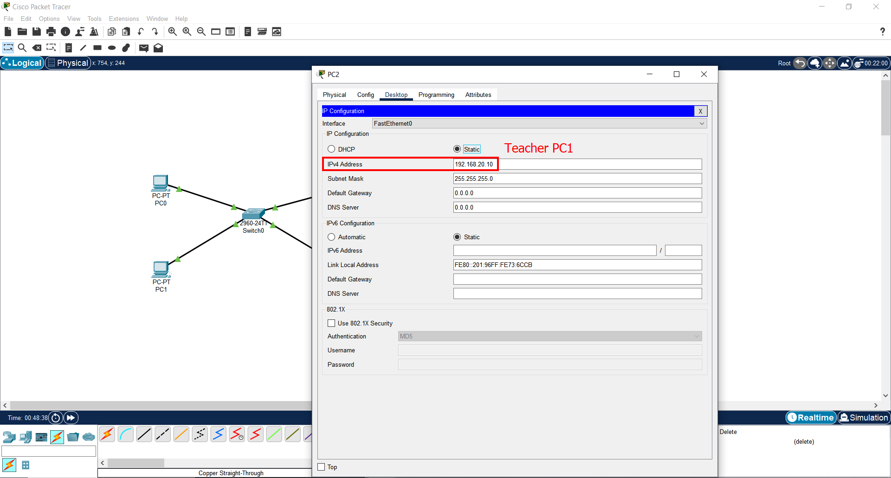

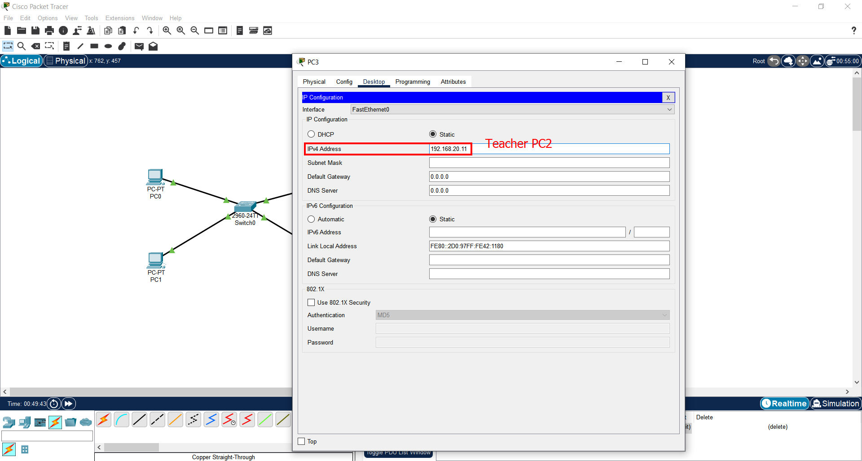

**Default VLAN (VLAN 1)**

* PC1: 192.168.1.10
* PC2: 192.168.1.11
* Laptop: 192.168.1.12

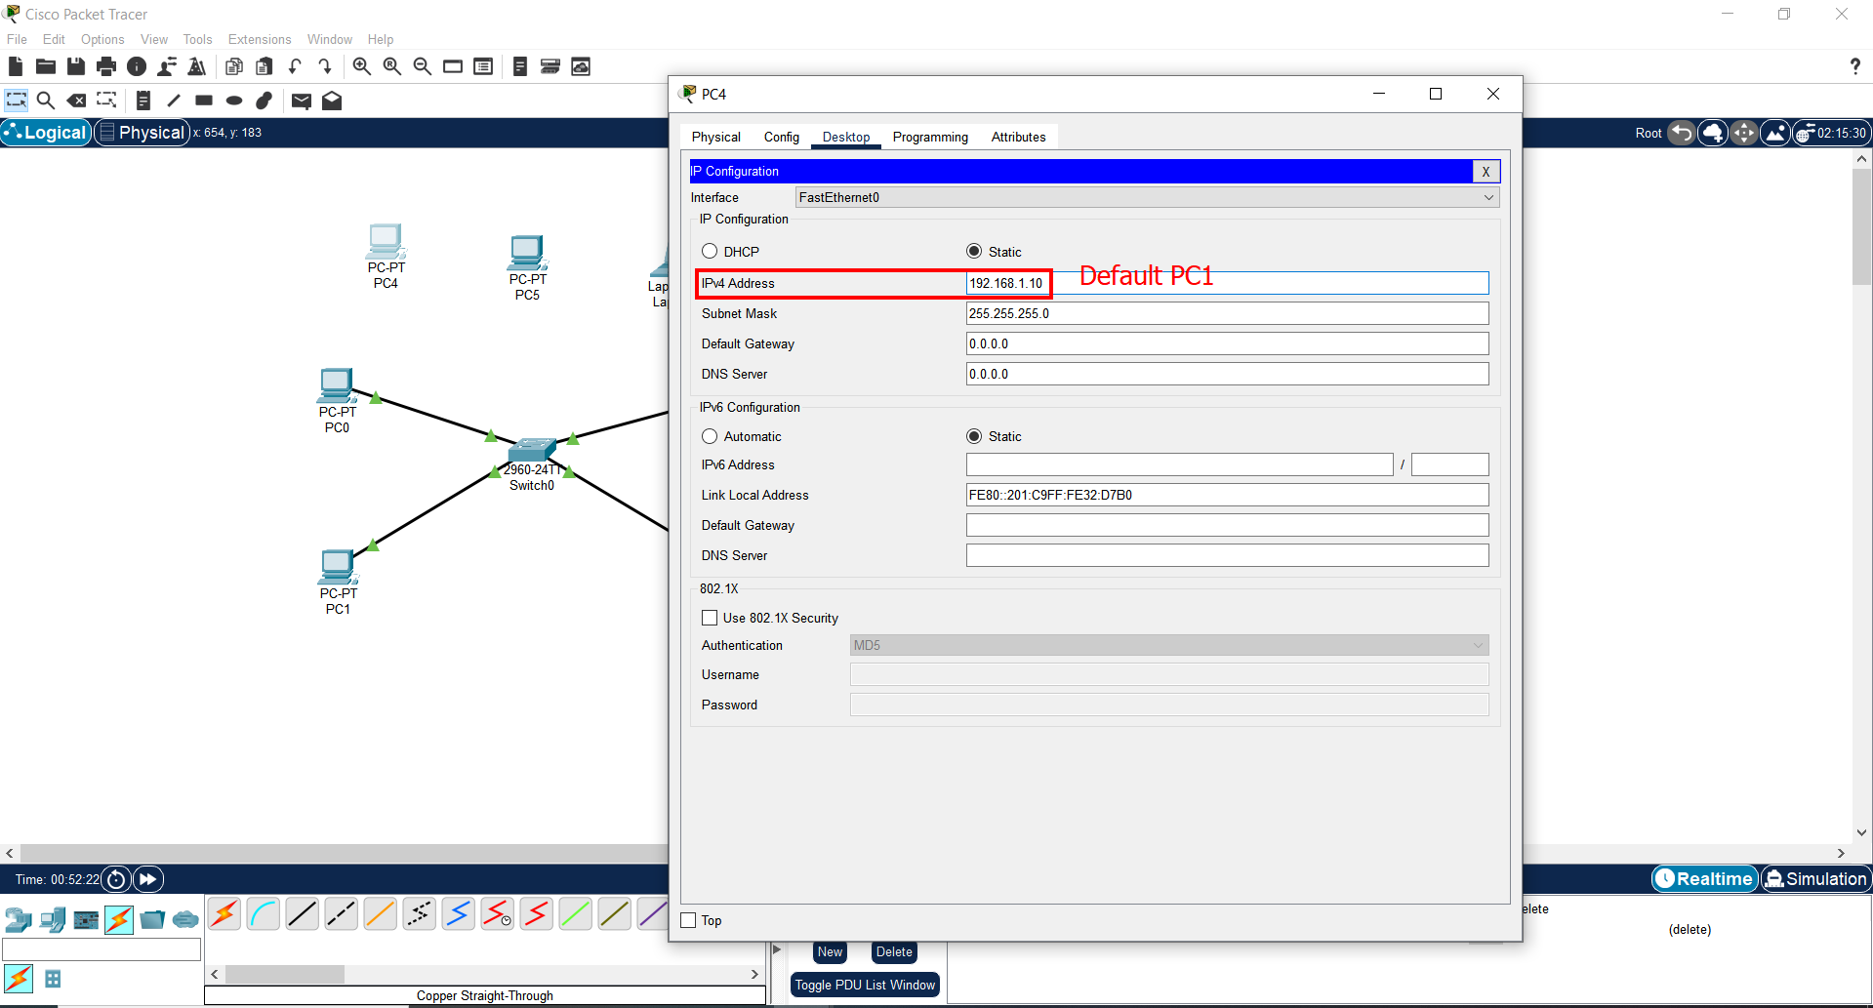

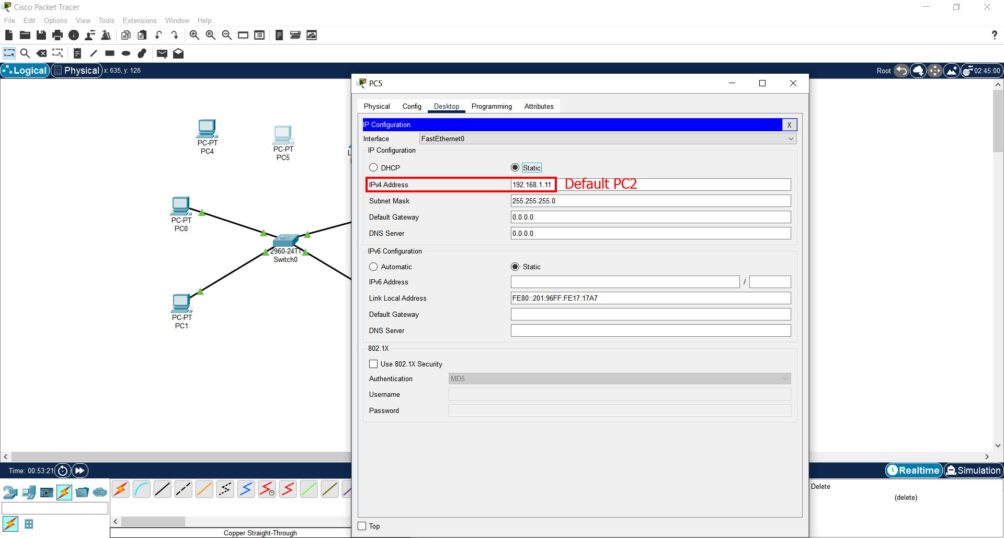

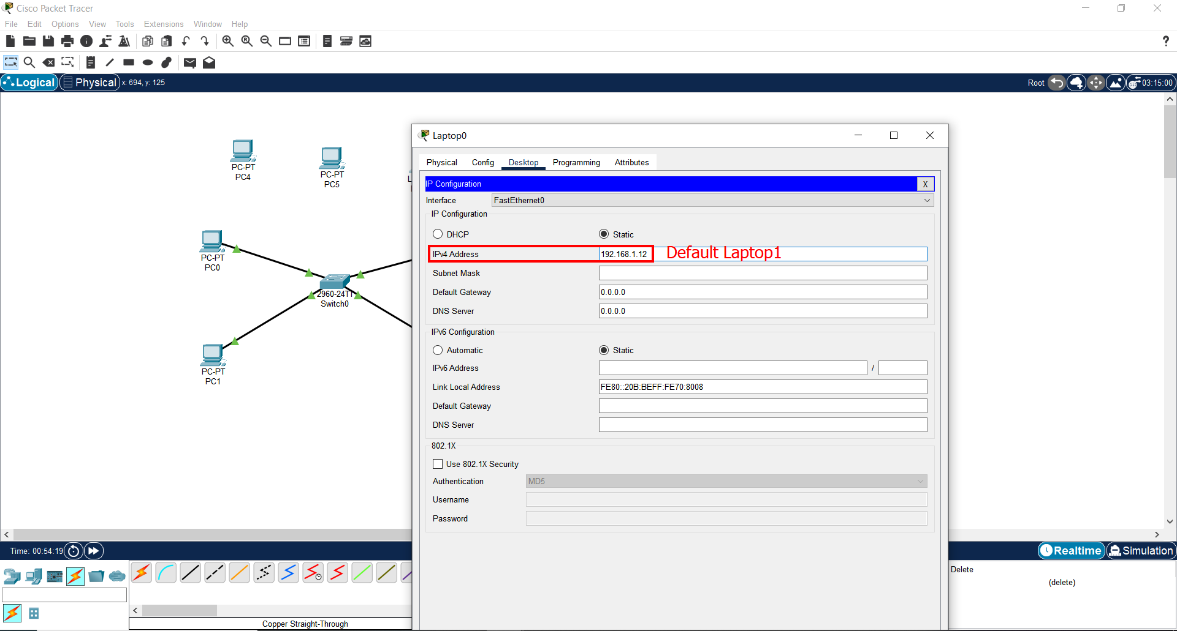

**Connect Devices to Switch:**

* Connect each PC and laptop to the switch using Copper Straight-Through cables.
* Assign the ports for each group (e.g., Student PCs to Fa0/1 and Fa0/2, Teacher PCs to Fa0/3 and Fa0/4, and Default VLAN devices to other available ports).

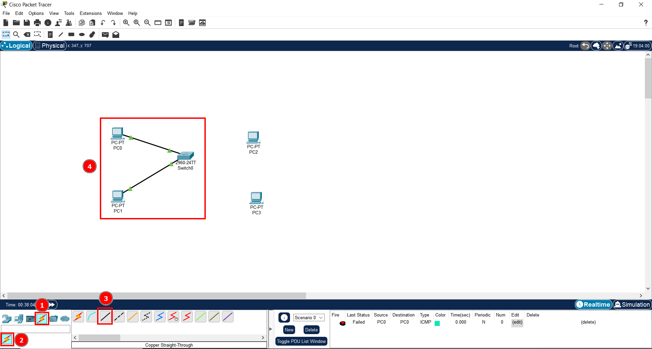

1. To make the devices communicate between them, we select the Connection button;
2. We select the Connections button again;
3. Between the available options, we select the Copper Straight-Through cable to connect the 2 PC’s to the switch;
4. This connection belongs to the Student PC’s parameter;

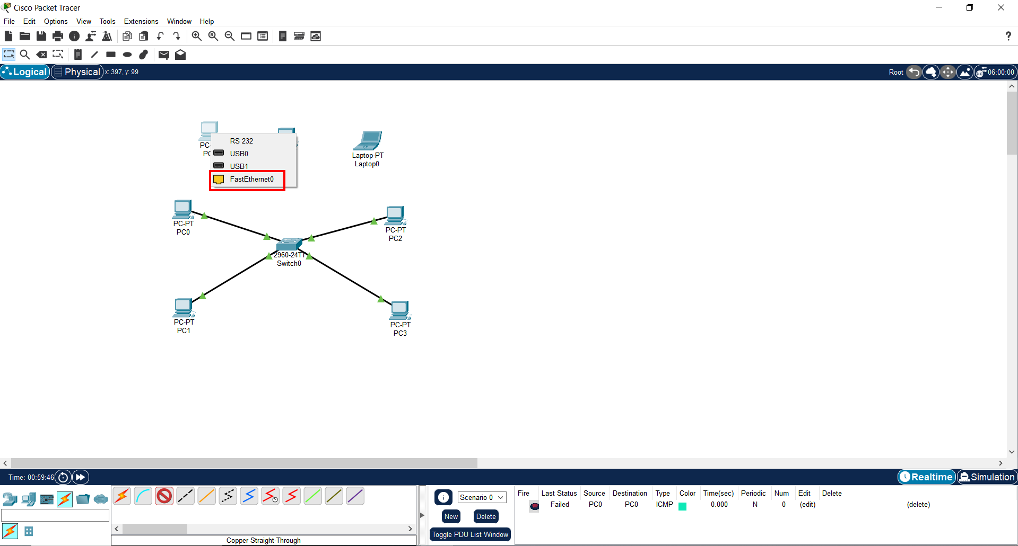

1. To assign a port to the device, we first select the cable (Copper Straight-Through);
2. Afterwards, we click on the device we want to connect, select the option FastEthernet0 and drag the arrow to the switch (and also click on it);

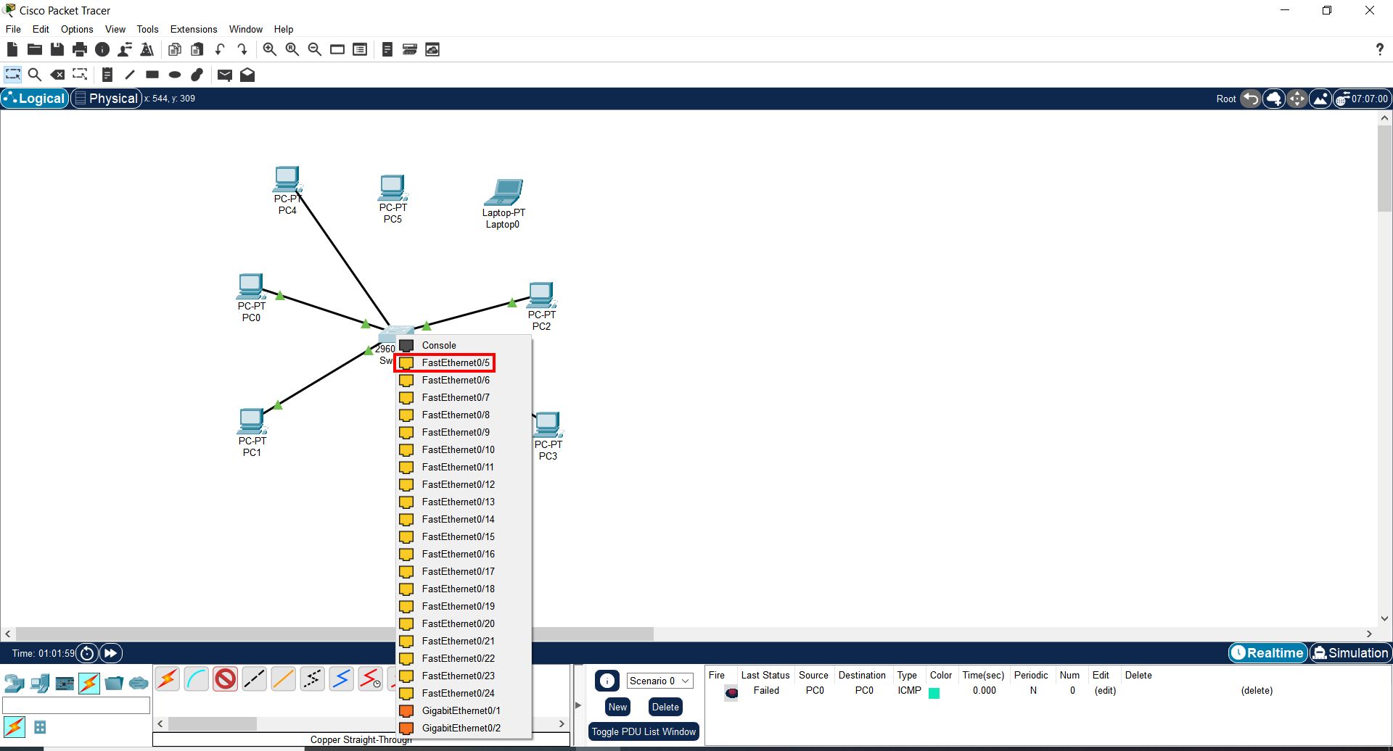

1. Now, we assign the device to the port available on the switch;

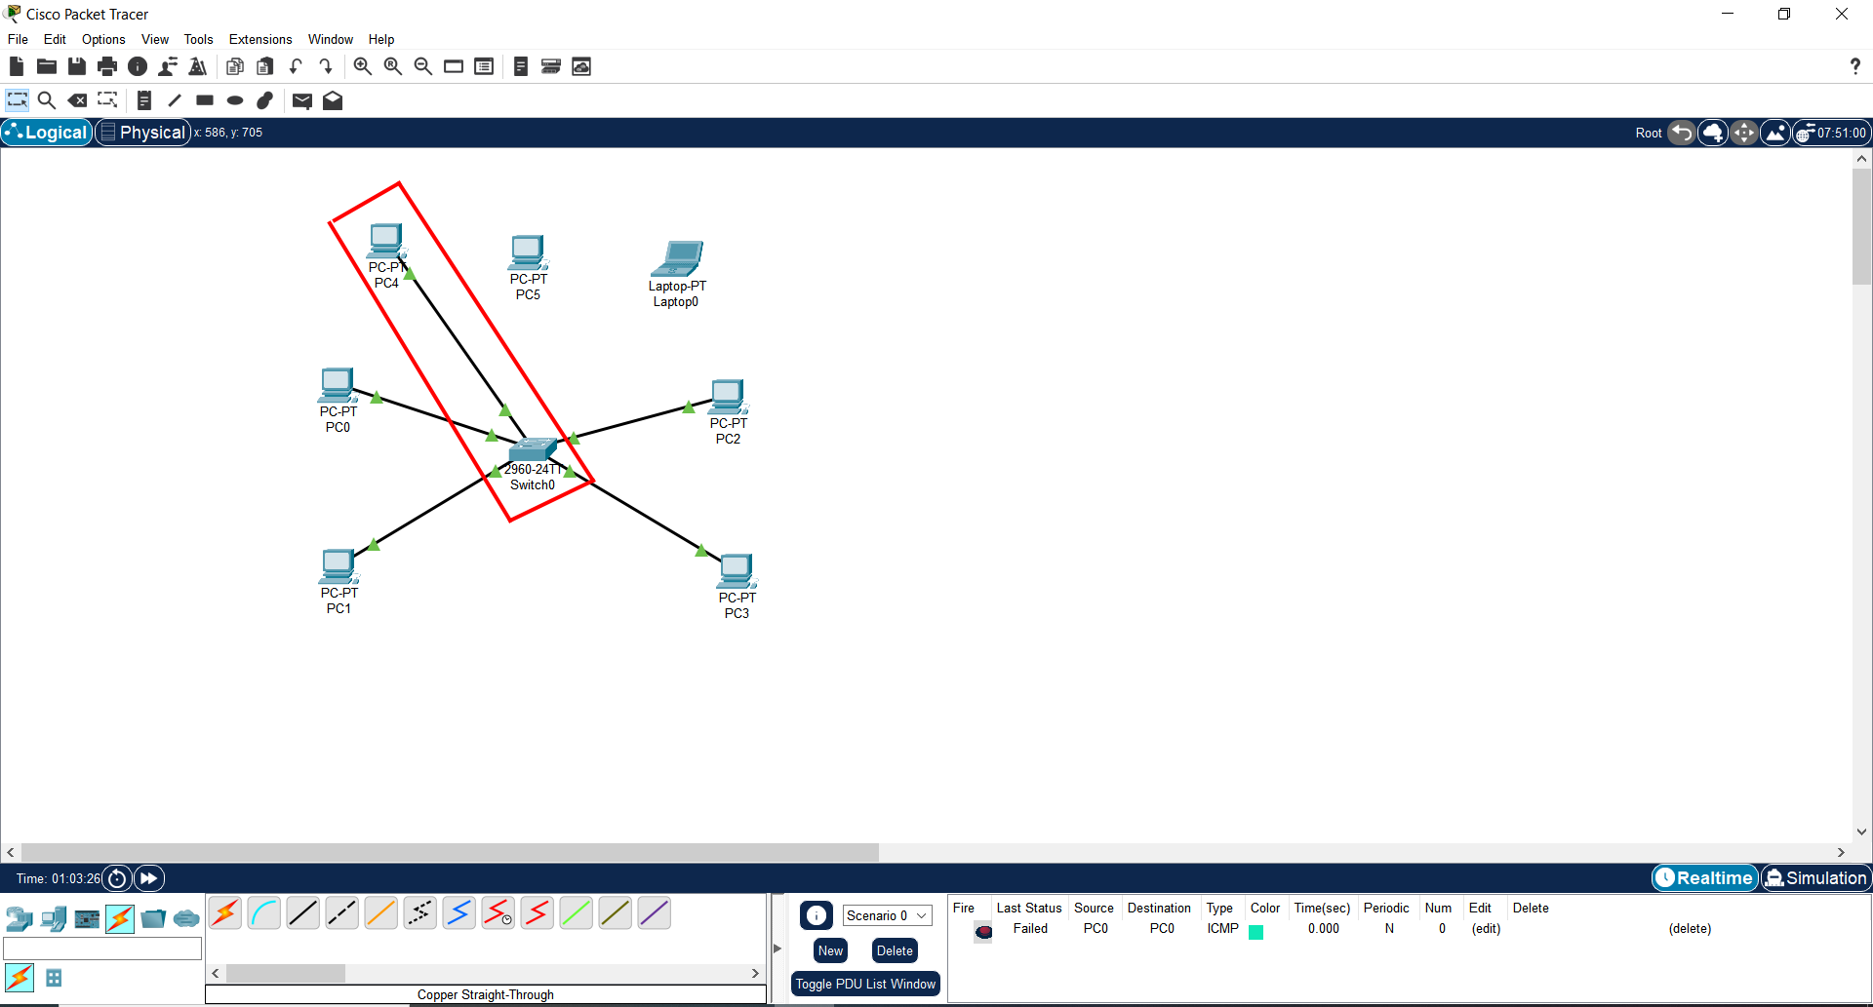

1. A connection is established;

**Important Note**: The procedure to assign ports is the same for all the devices.

## Part 2: Create VLANs and Assign Switch Ports

In this part, you will create VLANs for Students and Teachers on the appropriate switch and assign these VLANs to the correct interfaces.

**Steps:** Create VLANs on the Switch:

* On the Cisco 2960 Switch;
* Create Student VLAN (VLAN 10);
* Create Teacher VLAN (VLAN 20);

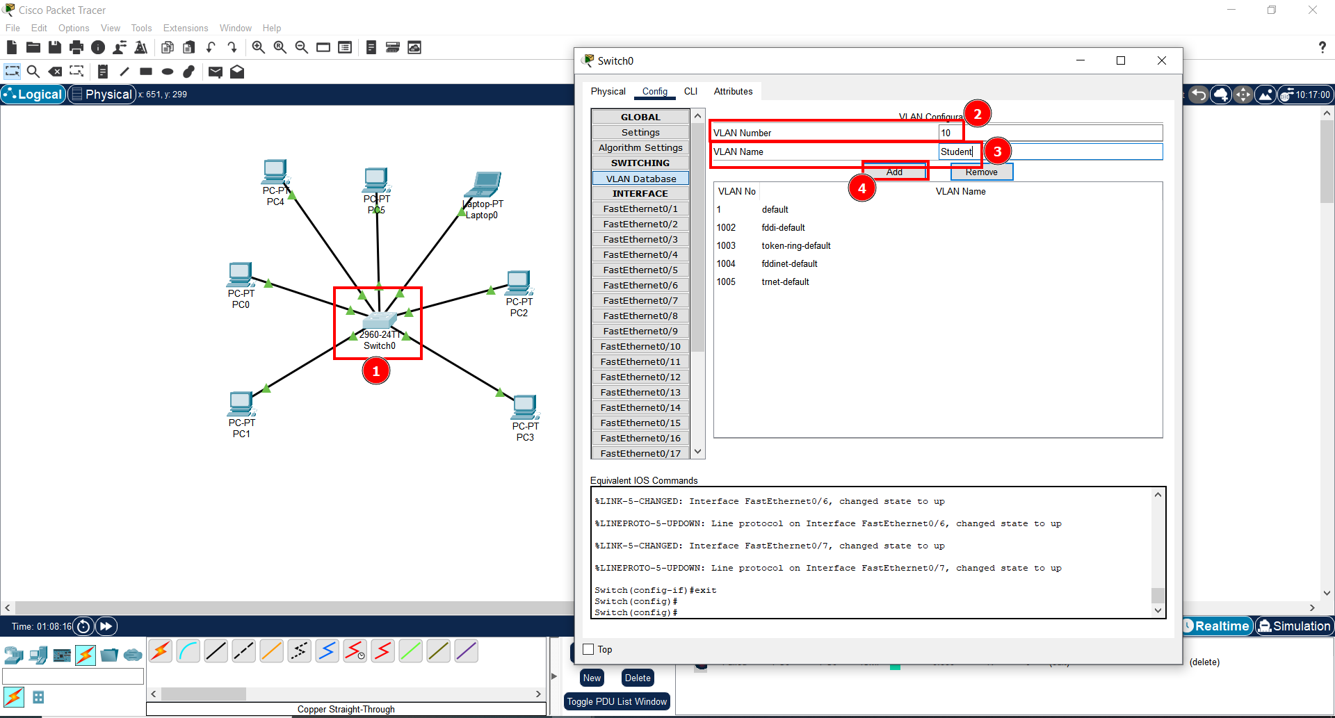

1. To create the Student VLAN, we click on the switch and a new window will open;
2. On the tab Configuration, inside the VLAN Database, we assign a new VLAN Number (for this VLAN is the number 10);
3. And then a VLAN Name (for this VLAN is Student);
4. After assigning all the parameters, we select the button Add;

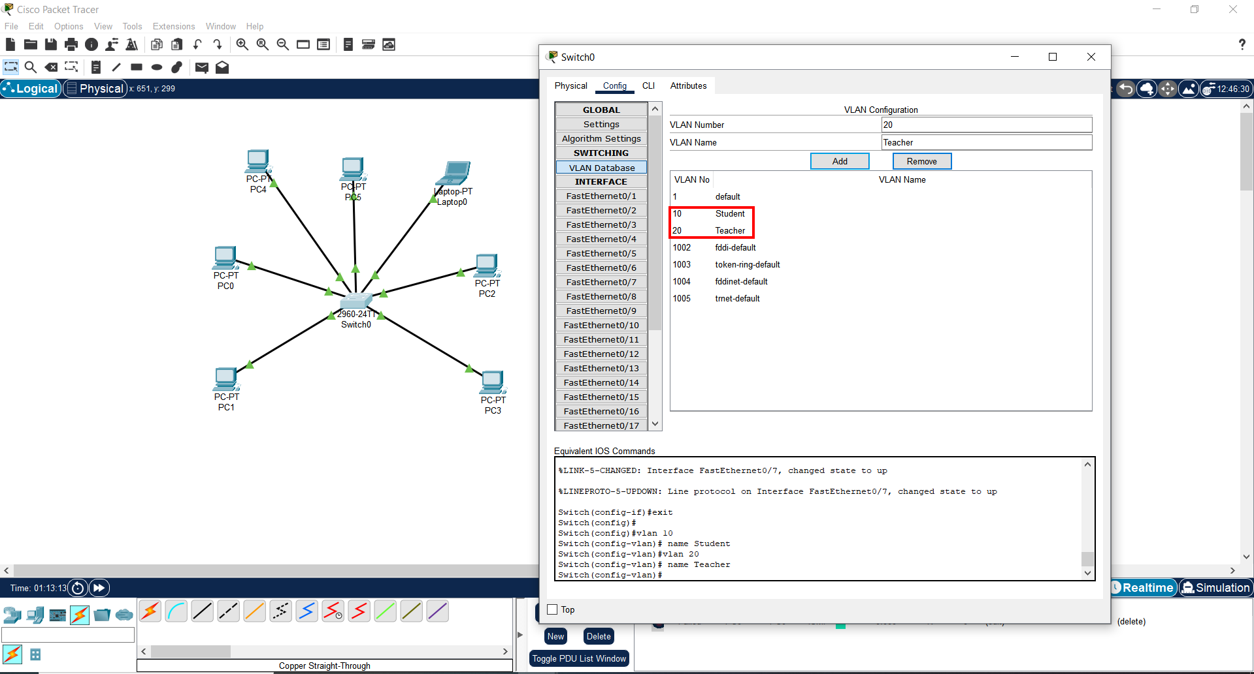

1. The Student VLAN and the Teacher VLAN were created in the switch;

**Assign VLANs to the Correct Switch Interfaces:**

* Assign the switch ports connected to the Student PCs to the Student VLAN (VLAN 10).
* Assign the appropriate ports (e.g., FastEthernet0/1 and FastEthernet0/2) to the Student VLAN (VLAN 10).

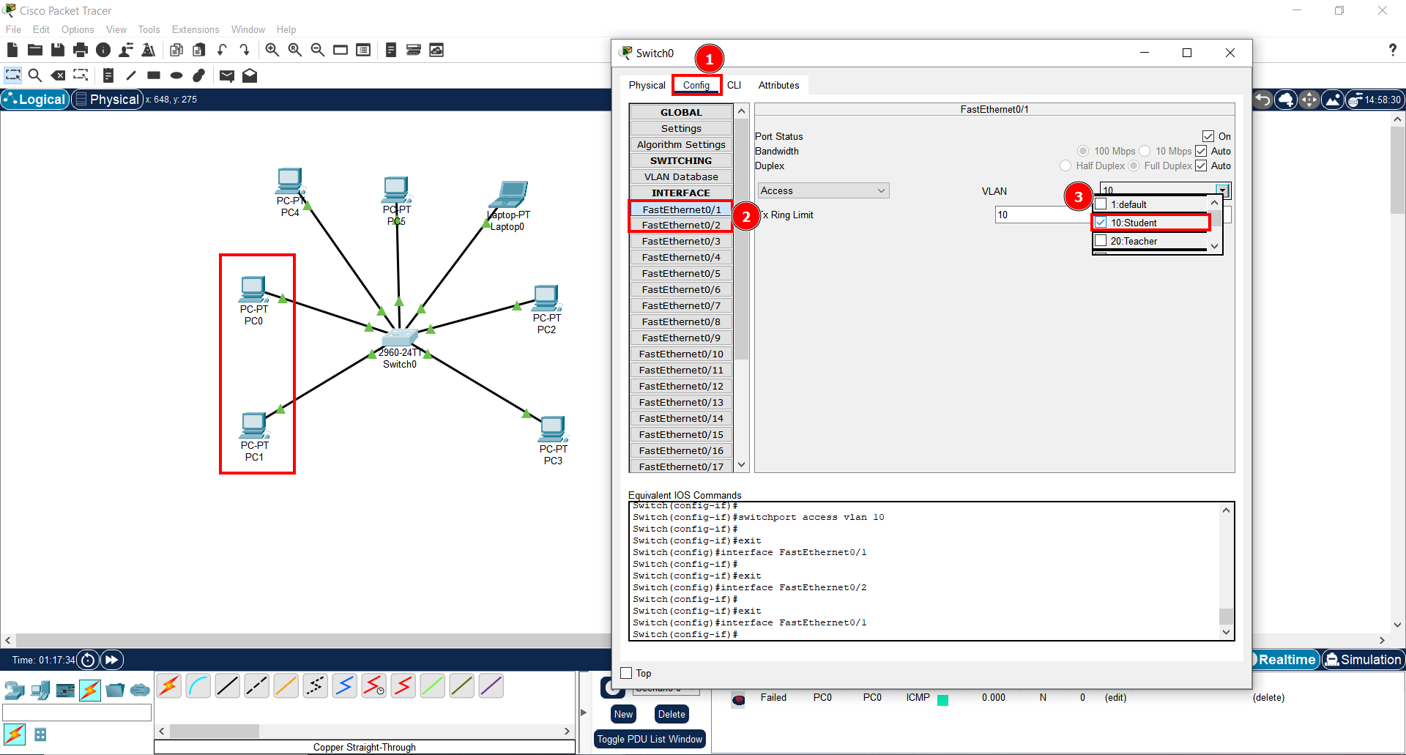

1. To assign the new Student switch port to the respective devices, we click on the switch and a new window will open. When open, we click on the tab Configuration;
2. Then, we select the devices we want to assign the new port;
3. Select the VLAN we want to assign (for the devices connected to the port 1 and 2 is the Student VLAN);

**Assign the switch ports connected to the Teacher PCs to the Teacher VLAN (VLAN 20).**

* Assign the appropriate ports (e.g., FastEthernet0/3 and FastEthernet0/4) to the Teacher VLAN (VLAN 20).

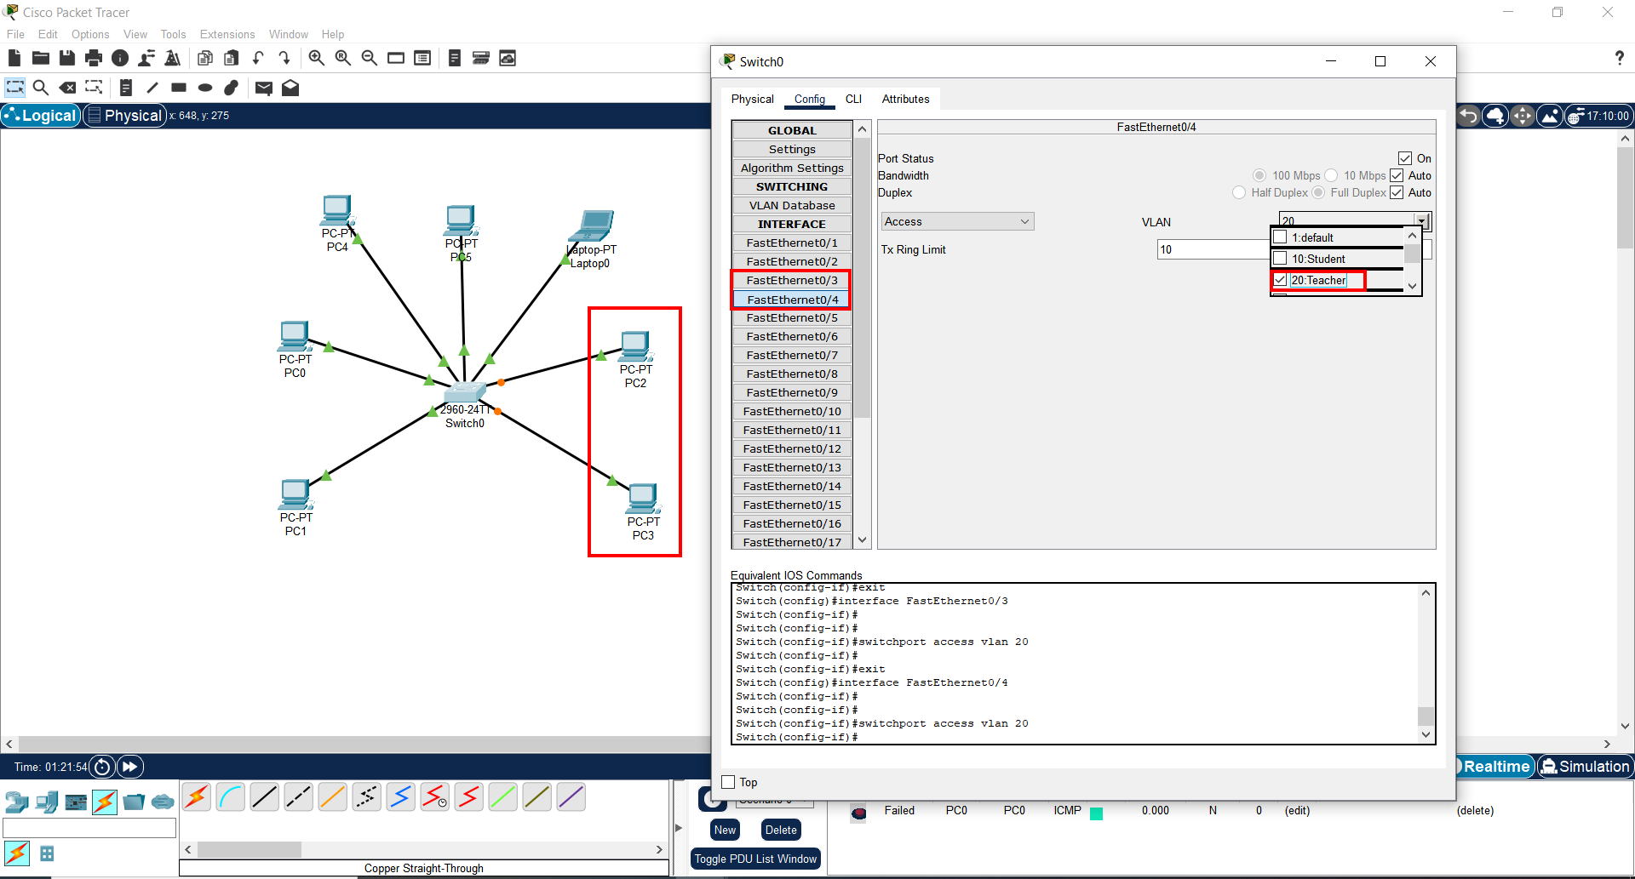

1. The same procedure is made for the devices connected to the ports 3 and 4, but instead we connect these 2 to the Teacher VLAN;

## Part 3: Testing Connectivity

**Steps:**

**Ping Between Devices Within the Same VLAN:**

* Test connectivity within the same VLAN by pinging from Student PC1 to Student PC2 and from Teacher PC1 to Teacher PC2. The pings should be successful if the devices are configured correctly.

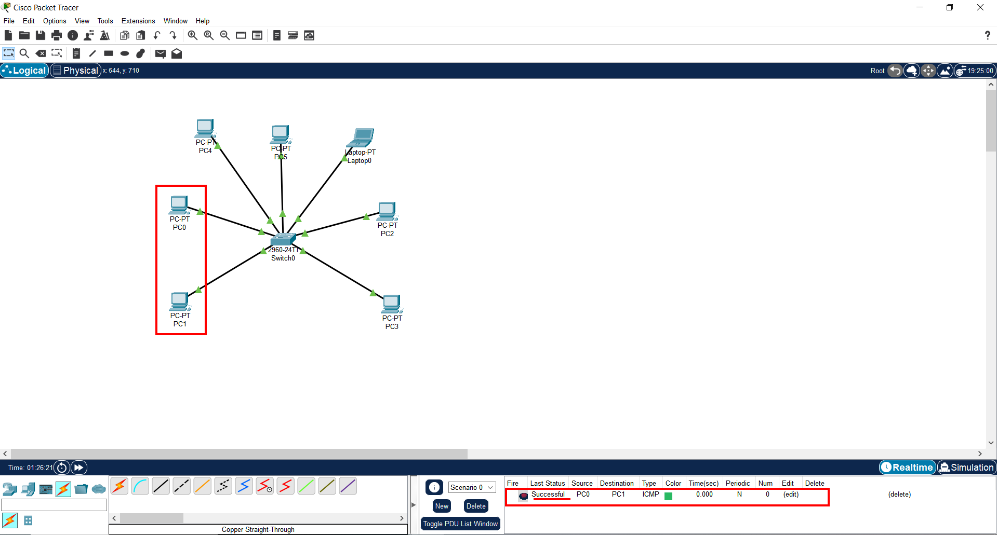

1. Ping connection between Students PC1 and PC2 successful;

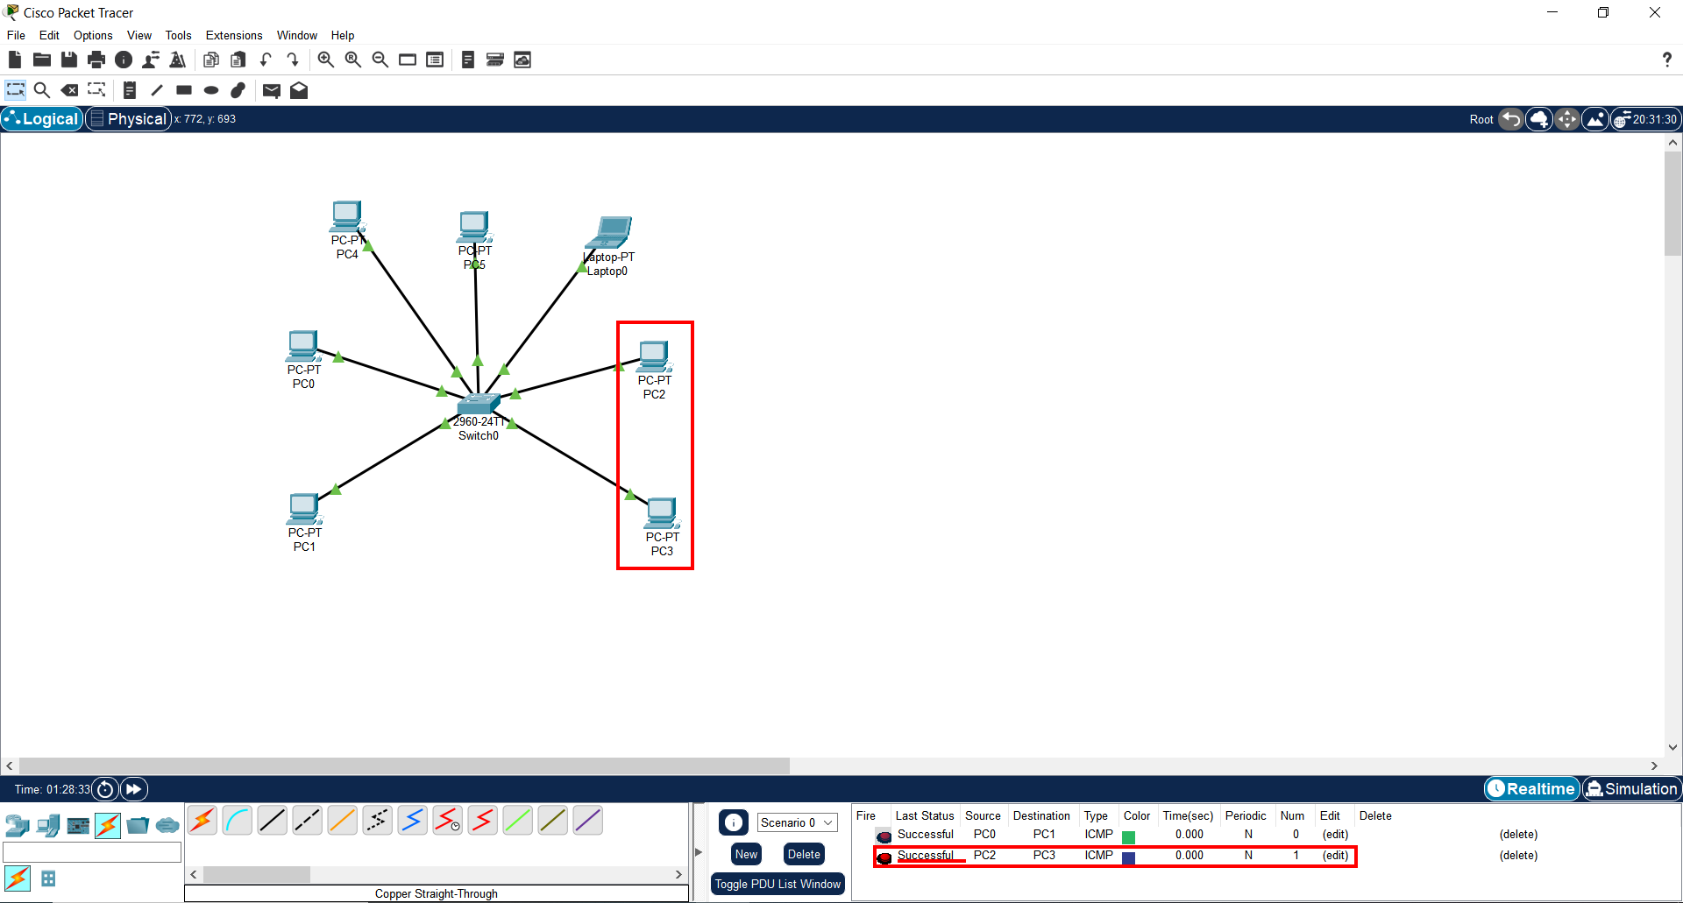

1. Ping connection between Teachers PC3 and PC4 is successful;

**Ping Between Devices in Different VLANs:**

* Attempt to ping between devices in different VLANs (e.g., from Student PC1 to Teacher PC1 or from Student PC1 to a Default VLAN device).
* The pings should fail because VLANs are separate broadcast domains, and without a router, inter-VLAN communication is not allowed.

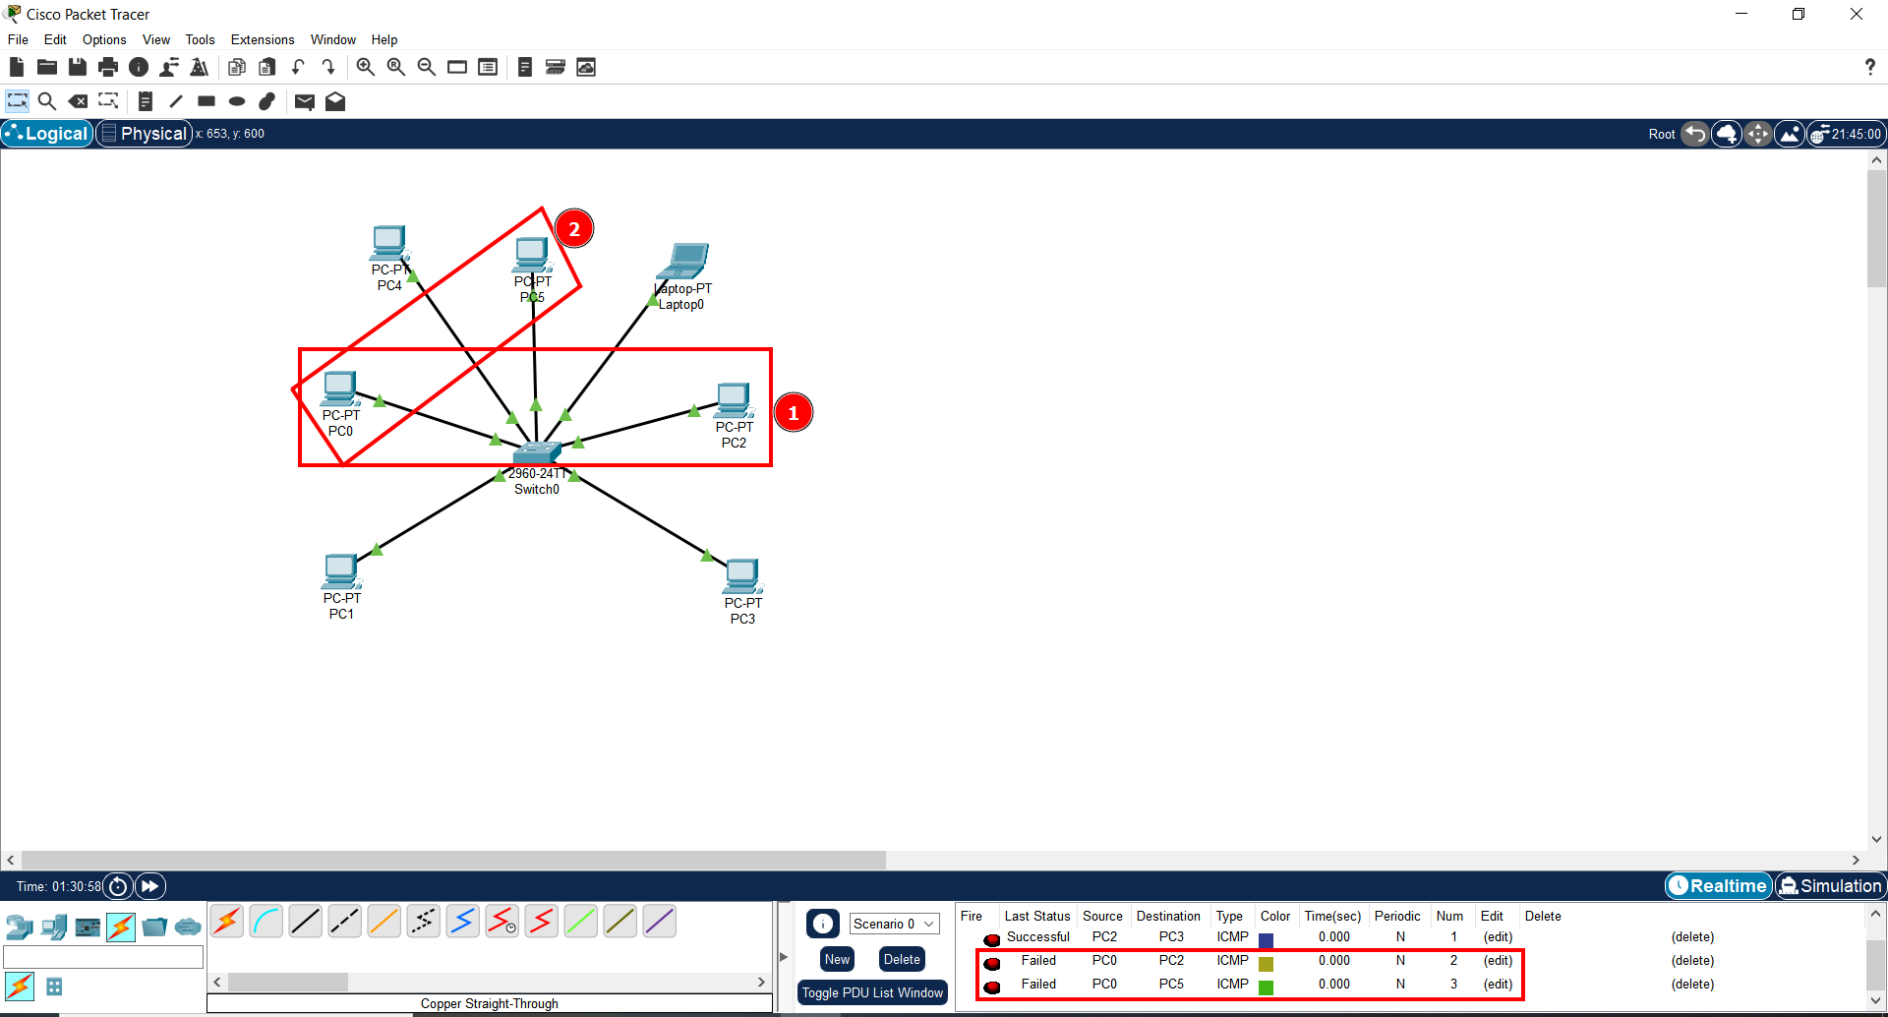

1. Both connection 1 and 2 failed;